Dongjiakou Vessel Traffic Services (Dongjiakou VTS)

- VHF Procedures
1 Sector
Dongjiakou VTS area consists of one sector, the working channel is VHF CH12. Vessels in Dongjiakou VTS area should call Dongjiakou VTS and keep watching on VHF Channel 12.
2 Other channels
Harbor control: VHF CH68
Pilot: VHF CH11
3 VTS area
Dongjiakou VTS area is the navigational waters enclosed by the first reporting line, Line joining point G (Latitude: 35°27＇11.5″N/Longitude: 119°50′49″E) and point F(Latitude: 35°27＇11.5″N/Longitude: 119°58′15.5″E) ,the south boundary of main fairway , the boundary of the prohibited area and the coastline of the port area,but Basin waters and the waters of quayside areas can’ t be effectively covered by VTS radars.
The first reporting line: Line joining point A (Latitude: 35°38′24″N/Longitude: 120°04′12″E) and point B (Latitude: 35°38′24″N/Longitude: 120°01′36″E), being abeam Qingshilan light beacon.
The second reporting line: Lines joining point C(Latitude: 35°23′N/Longitude: 120°03′E) , point D (Latitude: 35°18′N/Longitude: 119°57′E) and point E (Latitude: 35°35′N/Longitude: 119°38′E).
Schematic (this picture is not available for navigation):
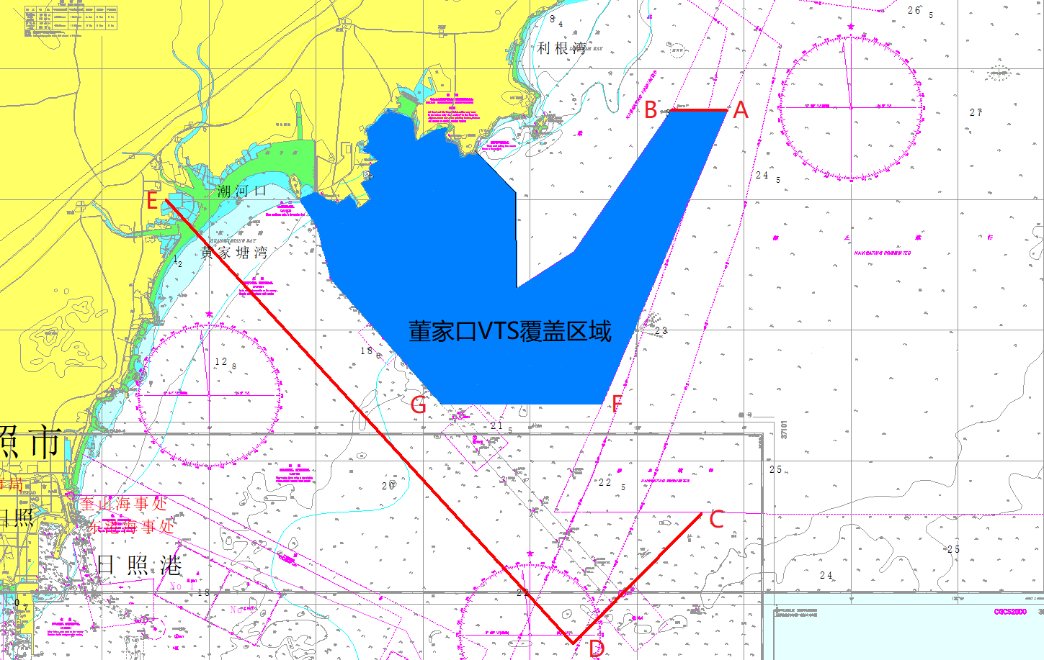
4 Working language: Mandarin or English
5 Working time: 0000-2400 (Beijing time)
- Reports
1 Applicable vessels
- Foreign vessels;
- Vessels registered in China of 300 GRT and more;
- Passenger vessels;
- Vessels carrying dangerous cargo;
- Vessels restricted in her ability to manoeuvre;
- Vessels engaged in the activities of receiving sewage, supplying oil and water, construction, barge operation etc.;
- Other vessels joining voluntarily to VTS reporting their movements.
2 Entry report
- WHEN: Passing VTS reporting line or before heaving up anchor in anchorage.
- TO: Dongjiakou VTS
- VIA: VHF CH12
- GIVING: Vessel (name, call sign), position, plan and other information required by the VTS.
3 Arrival report
- WHEN: The vessel arrives the berth or anchorage in the VTS area.
- TO: Dongjiakou VTS center
- VIA: VHF CH12
- GIVING: Vessel (name, call sign), time, position and other information required by the VTS.
4 Pre-move and Pre-departure report
- WHEN: Before departure or heaving up anchor in anchorage.
- TO: Dongjiakou VTS
- VIA: VHF CH12
- GIVING: Vessel (name, call sign), time, position, destination and other information required by the VTS.
5 Outbond report
- WHEN: Passing VTS reporting line .
- TO: Dongjiakou VTS
- VIA: VHF CH12
- GIVING: Vessel (name, call sign), time (time when passing the reporting line), position and other information required by the VTS.
6 Deviation reports
- WHEN: Any change in details given in the pre-entry report.
- TO: Dongjiakou VTS
- VIA: VHF CH12
- GIVING: Any changed information.
7 Accident report
- WHEN: Vessels involving in traffic accident or pollution.
- TO: Dongjiakou VTS
- VIA: VHF CH12
- GIVING: Full details of the accident.
8 Observations report
- WHEN: Observing any abnormal circumstance which may affect the navigation safety.
- TO: Dongjiakou VTS
- VIA: VHF CH12
- GIVING: Vessel and abnormal circumstance.
9 Activities report
- WHEN: a. Overhauling main engine, boiler,windlass, steering gear and
other equipment that may affect the ship’s maneuverability;
b. Navigation trial;
c. Addjusting compass;
d. Release lifeboat or liferaft;
e. Mooring side by side and overside delivery in anchorage;
f. Conducting the on-water or under-water operations;
g. Towing operations;
h.Engaged in sewage treatment 、oil and water supply operations ;h. Other operations that may affect navigation safety.
- TO: Dongjiakou VTS
- VIA: VHF CH12
- GIVING: Vessel (name, call sign), position and other information required by the VTS.
- Pilotage
1 Pilot report
- WHEN: After Pilot embarking or before disembarking.
- TO: Dongjiakou VTS
- VIA: VHF CH12
- GIVING: Pilot's name or number, vessel (vessel name, call sign), embarking or disembarking position, destination, etc.
2 Compulsory pilotage
Foreign Vessels.except where the provisions of the competent department of transportation under the State Council may be exempted after being submitted to the State Council for approval;
Nuclear - powered vessels , ships carrying radioactive substances , and VLCC ;
Bulk liquefied gas (LPG) vessels and bulk dangerous chemicals vessels that may endanger port security;
Vessel length, width and height are close to the limits of the navigation conditions of the channel.
3 Pilot Boarding Area
- LNG vessels and vessels with draft 19 metres and above.
Dongjiakou port NO.1 pilot boarding area:
Bounded by a line joining the following four positions :
35°20′.30N/119°59′.80E
35°18′.75N/120°01′.42E
35°17′.68N/119°59′.93E
35°19′.18N/119°58′.32E
- Vessels with draft 12 meters and above and less than 19 meters.
- Dongjiakou port NO.2 pilot boarding area:
Bounded by a line joining the following four positions :
35°27′.18N/119°52′.35E
35°25′.68N/119°53′.97E
35°24′.61N/119°52′.49E
35°26′.11 N/119°50′.86E
- Vessels with draft less than 12 meters.
- Dongjiakou port NO.3 pilot boarding area:
Bounded by a line joining the following four positions :
35°30′.66N/119°48′.04E
35°30′.13N/119°49′.00E
35°29′.25N/119°49′.00E
35°28′.66N/119°48′.35E
35°29′.90N/119°46′.97E
- Service provided
1 Information service
2 Navigational assistance service
3 Traffic organization service

- Other information
1 Special regulations
- In Dongjiakou VTS area, vessels participating in the VTS system shall keep watching on the VHF12 channel.
- Without approval, anchoring outside anchorage is prohibited.
- Without approval, navigation trial and/or speed-test in fairway and anchorage are prohibited.
- Without approval, mooring side by side and/or overside delivery in anchorage are prohibited.
2 Route regulations
- The direction of main channel of Dongjiakou port is 318°39′16′′～ 138°39′16′.
- LNG Vessels and vessels with draft more than 18.5 meters shall navigate in the main channel. Other vessels are recommended to use the main channel when entring and exiting the port.
- Under the conditions of safe navigation, the channel allows the maximum draft of the ship to not exceed 22.8 meters.
- Vessels of foreign nationality and those registered in Hong Kong, Macao and Taiwan of China are prohibited entering Lingshan Channel without approval.
3 Safety responsibility
- Under all circumstances, any service, information, advice, warning and instruction provided by Dongjiakou VTS are only reference for masters and pilots.
- Under all circumstances, Dongjiakou VTS operations do not exempt the master and the pilot from the responsibility for safe navigation and do not disturb the traditional relationship between them.
- Information inquiry
1 Related information publishing website URL
Shandong Maritime Safety Administration
http://www.sdmsa.gov.cn
2 Contact informationof the relevant organizations.
- Dongjiakou VTS center
Office add: Dongjiakou Shipping Center, West Coast New District, Qingdao City, Shan Dong province,P.R.China
Fax: 86-532-82989553
Tel: 86-532-82989550 82989551
Sea distress alarm special Tel: 86-532-12395
Email: djkvts@126.com
- Qingdao Pilot Station
Fax: 86-532-82985926
Tel: 86-532-82982389 82985930
- Dongjiakou Port Control.
Tel: 86-532-82989201 82989202 82989203

