附件2：
日照VTS用户指南
引言：本指南旨在向用户简明介绍日照船舶交通管理系统（以下称日照VTS系统）的概况、日照船舶交通管理中心（以下称日照VTS中心）有关船舶交通管理和服务方面的要求，以保障船舶航行安全，提高交通效率，保护水域环境，增进VTS中心和用户之间的理解和合作。

日照VTS系统的组成：
日照VTS中心（35°23′.4N, 119°31′.0E）
东港雷达站（35°21′.3N, 119°33′.0E）
甜水河雷达站（35°06′.7N, 119°21′.6E）
日照VTS系统的主要技术设备及性能：
雷达监控系统：16海里作用距离，具有自动跟踪与重放功能。
船舶数据处理系统：船舶数据处理能力5000艘次。
VHF通信系统：24海里作用距离，具有录音功能。
AIS系统：24海里作用距离，具有船舶识别和发送/接受AIS 信息功能。
管理和服务对象：
1、外国籍船舶；
2、500总吨及以上中国籍船舶；
3、客船；
4、载运危险货物的船舶；
5、操纵能力受到限制的船舶；
6、其他自愿参加VTS动态报告的船舶。
管理和服务区域：
1、日照管理服务区：以下六点连线内水域。
A:35°22′.9N 119°33′.7E
B:35°23′.7N 119°38′.8E
C:35°19′.0N 119°49′.0E
D:35°10′.7N 119°43′.7E
E:35°16′.4N 119°30′.5E
F:35°20′.3N 119°30′.5E
2、岚山管理服务区：以下六点连线内水域。
A:35°10′.5N 119°23′.0E
B:35°09′.5N 119°30′.4E
C:35°09′.5N 119°40′.6E
D:35°00′.0N 119°40′.6E
E:35°00′.0N 119°25′.7E
F:35°04′.7N 119°21′.1E
日照VTS中心依据有关法律法规、规章和其他规范性文件在日照VTS区域实施船舶交通管理，提供交通服务。
VTS雷达盲区：
VTS区域内存在VTS雷达盲区，在VTS雷达盲区内，VTS中心仅应请求向船舶提供信息服务。船舶在VTS雷达盲区内航行时，应特别谨慎地驾驶。
日照VTS雷达盲区：以下四点连线内水域A:35°22′.7N 119°32′.0E；B:35°22′.7N 119°33′.3E；C:35°21′.3N 119°32′.8E；D:35°21′.3N 119°32′.0E和以下四点连线内水域A:35°20′.7N 119°31′.8E；B:35°17′.5N 119°31′.8E；C:35°17′.5N 119°30′.5E；D:35°20′.3N 119°30′.5E。
岚山VTS雷达盲区：以下四点连线内水域A:35°10′.5N 119°23′.0E；B:35°10′.2N 119°25′.1E；C:35°06′.3N 119°25′.8E；D:35°03′.3N 119°22′.6E。
工作语言：汉语普通话和英语
工作时间：北京时间 每日0000－2400
日照船舶交通管理中心联系方式：
通信地址： 中国山东日照市北京路中段
日照海事局船舶交通管理中心
邮政编码： 276826
联系电话： +86-633-8385429
传 真： +86-633-8387838
电子信箱： rizhaovts@163.com

RIZHAO VTS GUIDE FOR USERS

INTRODUCTION: This guide is intended to provide users with a brief introduction on Rizhao vessel traffic service system(hereinafter referred to as Rizhao VTS system ), including the requirements of Rizhao vessel traffic service center(hereinafter referred to as Rizhao VTS Center)about vessel traffic control and services, in order to ensure the safety of navigation, to raise the traffic efficiency, to protect the marine environment, and to promote the understanding and cooperation between users and VTS Center.

The components of Rizhao VTS system:
Rizhao VTS center(Lat.35°23′.4N , Long. 119°31′.0E)
Donggang Rader station(Lat.35°21′.3N , Long. 119°33′.0E)
Tianshuihe Rader station(Lat.35°06′.7N , Long. 119°21′.6E)
The main technical equipment and functions of Rizhao VTS system:
Rader Surveillance System: effective range of 16 nautical miles with tracking and replay functions.
Ship Data Processing System: 5,000 ships’ data processing capacity.
VHF Communication System: effective range of 24 nautical miles with voice recording function.
Automatic Identification System（AIS）：effective range of 24 nautical miles with the function of ships’ identification and transmitting/receiving messages.
Management and service object (Users):
1. Foreign vessels
2. Vessels registered in China of 500 GRT or more
3. Passenger vessels
4. Vessels carrying dangerous cargo
5. Vessels restricted in her ability to manoeuvre
6.Other vessels joining voluntarily to VTS reporting their movements.
Management and service area:
1. Management and service area of Rizhao port: covering the waters surrounded by the coastline and joint lines connecting the following six points:
A:35°22′.9N 119°33′.7E
B:35°23′.7N 119°38′.8E
C:35°19′.0N 119°49′.0E
D:35°10′.7N 119°43′.7E
E:35°16′.4N 119°30′.5E
F:35°20′.3N 119°30′.5E
2. Management and service area of Lanshan port: covering the waters surrounded by the coastline and joint lines connecting the following six points:
A:35°10′.5N 119°23′.0E
B:35°09′.5N 119°30′.4E
C:35°09′.5N 119°40′.6E
D:35°00′.0N 119°40′.6E
E:35°00′.0N 119°25′.7E
F:35°04′.7N 119°21′.1E
Rizhao VTS Center exercises vessel traffic management and provides traffic services within the VTS area in accordance with national laws, codes, regulations and other government documents.
Radar blind area:
Radar blind area exists in the VTS area. In the radar blind area, VTS center just provides information service on request and vessels should navigate with caution.
Radar blind area of Rizhao port: the water area within the joint lines connecting the following four points:
A:35°22′.7N 119°32′.0E
B:35°22′.7N 119°33′.3E
C:35°21′.3N 119°32′.8E
D:35°21′.3N 119°32′.0E
and connecting the following four points:
A:35°20′.7N 119°31′.8E
B:35°17′.5N 119°31′.8E
C:35°17′.5N 119°30′.5E
D:35°20′.3N 119°30′.5E
Radar blind area of Lanshan port: the water area surrounded by the coastline and joint lines connecting the following four points
A:35°10′.5N 119°23′.0E
B:35°10′.2N 119°25′.1E
C:35°06′.3N 119°25′.8E
D:35°03′.3N 119°22′.6E
Working language: Chinese and/or English
Working time: 0000--2400(Beijing time)
Contact to Rizhao VTS Center:
Add: Beijing Road, Rizhao, Shandong Province, P. R. China
(Rizhao VTS center, Rizhao MSA)
Post code: 276826
Tel: +86-633-8385429
Fax: +86-633-8387838
E-mail: rizhaovts@163.com
航 路 规 则
Route Regulations
（一）禁止船舶在航道、港池和其他禁锚区锚泊，紧急情况下锚泊必须立即报告VTS中心。
Anchoring in the channel，basin or the other forbidden anchor area are prohibited. If anchoring in emergency situation, shall report to VTS center at once.
（二）在VTS区域内, 客船最高航速不得超过15节，其他船舶最高航速不得超过12节。
In the VTS area, all vessels shall proceed with the speed not exceeding 12 knots, except for the passenger vessel, the speed of which should not exceed 15 knots.
（三）未经VTS中心同意，禁止船舶在港池及航道内追越。

Without approval, overtaking is prohibited in the basin and channel.
（四）进出港池的船舶，禁止在防波堤口门会遇。
Vessels entering or leaving the basin are prohibited from meeting at the entrance of the breakwater.

船 舶 报 告
Ships Report
日照VTS报告线：
是以A点（35°22′.9N 119°33′.7E）、B点（35°23′.7N 119°38′.8E）、C点（35°19′.0N 119°49′.0E）、D点（35°10′.7N 119°43′.7E）、E点（35°16′.4N 119°30′.5E）、F点（35°20′.3N 119°30′.5E）六点依次连线。
岚山VTS报告线：
是以A点（35°10′.5N 119°23′.0E）、B点（35°09′.5N 119°30′.4E）、C点（35°09′.5N 119°40′.6E）、D点（35°00′.0N 119°40′.6E）、E点（35°00′.0N 119°25′.7E ）、F点（35°04′.7N 119°21′.1E）六点依次连线。
Rizhao VTS reporting line:
The joint line connecting the following six points: A (35°22′.9N 119°33′.7E), B（35°23′.7N 119°38′.8E）, C（35°19′.0N 119°49′.0E）, D（35°10′.7N 119°43′.7E）, E（35°16′.4N 119°30′.5E）, F（35°20′.3N 119°30′.5E）.
Lanshan VTS reporting line:
The joint line connecting the following six points: A（35°10′.5N 119°23′.0E）, B（35°09′.5N 119°30′.4E）, C（35°09′.5N 119°40′.6E）, D（35°00′.0N 119°40′.6E）, E（35°00′.0N 119°25′.7E ）, F（35°04′.7N 119°21′.1E）.

报告类别  Types of Report | 报告时间或位置  Reporting Time or Position | 报告内容  Reporting Contents | 通信频道  Working Channel
驶入报告  Entry report | 报告线：日照VTS管理服务区报告线和岚山VTS管理服务区报告线  Reporting line: Arriving at Rizhao VTS reporting line and Lanshan VTS reporting line | 船名、呼号、船位以及VTS要求的其他信息  Ship’s name, call sign, position and other required information | 日照管理服务区：VHF14频道呼叫日照交管Management and service area of Rizhao port(Call Rizhao VTS on CH14)  岚山管理服务区：VHF09频道呼叫岚山交管Management and service area of Lanshan port(Call Lanshan VTS on CH09)
到达报告  Arriving Report | 船舶靠泊或者锚泊后  After berthing or anchoring | 船名、泊位或锚位、完成时间  Ship’s name, berth or anchoring position, finishing time
动态报告  Moving Report | 拟进行抛锚、起锚、移锚、移泊等活动时  Before dropping/heaving up anchor and shifting | 船名、预抵泊位或锚地  Ship’s name, berth number or anchorage
开航报告  Departure Report | 离泊或由锚地起锚开航前  Before departure from berth or heaving up anchor | 船名、位置、下一港口  Ship’s name, departure position, next port of call
最终报告  Final report | 船舶驶离报告线  Departing the report line | 船名和位置  Ship’s name, position
作业报告  Activities Report | 进行下列作业时，船舶或人员应在作业前和结束后向VTS中心报告。  1.拆检主机、舵机、锚机、锅炉以及其他影响船舶操纵性能的设备；  2.试车、试航；  3.锚地并靠作业；  4.拖航船舶或船组解系缆作业；  5.其他可能影响通航安全的作业。  When carrying out the following operations, before operation and after the end of operation, ship and\or person involved should report to VTS center.  1.Overhauling main engine, maintenance of steering gear, windlass, boiler and other important navigational equipments  2.Testing main engine, ship trail  3.Mooring side by side in anchorage  4.Towing vessels engaged in mooring operation  5.Other operations impairing the safety of navigation | 船名、当前位置、活动内容以及VTS要求的其他信息  Ship’s name, position, contents of activities and other information required by the VTS
紧急报告  Emergency Report | 发生或发现交通事故、污染事故、机损事故、人员意外伤亡或其他紧急情况  When involved in or finding any traffic accident, pollution incident, engine damage, injury of persons or any other emergent situation | 船名、位置、紧急情况以及VTS要求的其他信息  Ship’s name, position, type of emergencies and other information required by the VTS | 当发生或发现紧急或异常情况时,应使用一切手段向VTS中心报告  When involved in or finding any emergency or abnormality, the vessels shall report to VTS center by all effective means.
异常报告  Abnormal Report | 发现助航标志或导航设施异常、有碍航行安全的碍航物、漂流物或其他妨碍航行安全的异常情况  When finding abnormality of navigation aids, leading marks, obstacles, drifting objects or any other unusual circumstances impairing the safety of navigation | 船名、位置、异常情况以及VTS要求的其他信息  Ship’s name, position, the abnormal circumstances and other information required by the VTS

引 航  Pilotage | 强制引航  下列船舶在日照水域航行或移泊应当向日照港引航站申请引航：  1. 外国籍船舶；  2. 靠离日照港区煤1、煤2专用码头的船舶；  3. 其他要求引航的船舶。  Pilotage Compulsory  Following vessels must apply to Rizhao Pilot Station for pilotage when navigating or shifting berth within Rizhao Port waters:  1. Foreign vessels;  2. Vessel berthing or unberthing from Coal Terminal No.1 and No.2 of Rizhao port;  3. Other vessels requiring pilotage.  日照港区引航员登轮水域  一号登轮水域：以35°18′.28N 119°38′.48E为圆心，半径为750米的圆形水域，船舶吃水＜16米；  二号登轮水域：以35°17′.30N 119°40′.82E为圆心，半径为750米的圆形水域，16米≤船舶吃水＜19.5米；  三号登轮水域：以35°16′.48N 119°46′.68E为圆心，半径为750米的圆形水域，船舶吃水≥19.5米。  Rizhao Port Pilot Boarding Area  Area 1: the water area with 35°18′.28N /119°38′.48E as the center and 750m as the radius(vessel’s draft less than 16m);  Area 2: the water area with 35°17′.30N/119°40′.82E as the center and 750m as the radius(vessel’s draft 16m or more, and less than 19.5m);  Area 3: the water area with 35°16′.48N/119°46′.68E as the center and 750m as the radius(vessel’s draft 19.5m or more).  岚山港区引航员登轮水域  南作业区一号登轮水域：以35°02′.25N 119°30′.00E为圆心，半径为500米的圆形水域，船舶吃水＜14米且船长＜250米；  南作业区二号登轮水域：以35°02′.80N 119°37′.77E为圆心，半径为500米的圆形水域，船舶吃水≥14米或船长≥250米；  中作业区一号登轮水域：以35°04′.50N 120°02′.50E为圆心，半径为1500米的圆形水域，限VLCC, 吃水≥20米；  中作业区二号登轮水域：以35°07′.50N 119°46′.00E为圆心，半径为1000米的圆形水域，限VLCC, 吃水＜20米。  Lanshan Port Pilot Boarding Area  South area 1：the water area with 35°02′.25N/119°30′.00E as the center and 500m as the radius(vessel’s draft less than14m and L.O.A. less than 250m);  South area 2：the water area with 35°02′.80N/119°37′.77E as the center and 500m as the radius(vessel’s draft 14m or more and/or L.O.A. 250m or more);  Middle area 1：the water area with 35°04′.50N/120°02′.50E as the center and 1500m as the radius(VLCC only, vessel’s draft 20m or more);  Middle area 2：the water area with 35°07′.50N/119°46′.00E as the center and 1000m as the radius (VLCC only, vessel’s draft less than 20m).  引航员应在规定的引航登（离）轮水域上下船。  Pilots should board (disembark) at the specified water areas.  引航员引领船舶, 应向VTS中心报告登（离）船的船名、时间、地点、引航员姓名或编号以及所领船舶的动态。  Pilot should report to VTS center on the ship’s name, time, position, pilot’s name or ID number and the ship’s movements.
交通服务  Service | VTS中心可提供：  1. 气象信息  2. 航行警（通）告信息  3. 交通信息  4. 交通组织服务  5. 助航服务（应请求）  6. 支持联合行动（应请求）  Rizhao VTS Center can provide:  1. Meteorology information  2. Navigational warning （notice）to mariners  3. Traffic information  4. Traffic organization  5. Navigation assistance (on request)  6. Information for supporting the allied activities (on request)
通航敏感水域  Sensitive Navigable Area | （一）倾废区  日照港区倾废区在以下四点连线内：  A.35°17′.00N，119°36′.10E  B.35°17′.00N，119°36′.90E  C.35°18′.27N，119°36′.10E  D.35°18′.27N，119°36′.90E  岚山港区倾废区：倾废区1以中心坐标35°00′.00N，119°24′.00E，半径1.5千米圆形区域内；倾废区2以中心坐标35°11′.00N，119°39′.38E，半径1.0千米圆形区域内.  Dumping Area  The dumping area of Rizhao Port :within the joint line connecting the following four points  A.35°17′.00N，119°36′.10E  B.35°17′.00N，119°36′.90E  C.35°18′.27N，119°36′.10E  D.35°18′.27N，119°36′.90E  The dumping area of Lanshan Port：  dumping area 1 : the circle area with the center at 35°00′.00N，119°24′.00E, and the radius of 1500m;  dumping area 2: the circle area with the center at 35°11′.00N，119°39′.38E and the radius of 1000m.  （二）养殖区  日照港、岚山港及附近海域存在较多养殖区域，其位置随着季节的变化而变化，同时有大量渔船出入。  Cultivation area  Cultivation area exists in the water area of Rizhao Port，Lanshan Port and adjacent waters, the location of which may change at different season. Meanwhile, many fishing vessels exist in these areas.

日照和岚山管理服务区
Management and service areas of Rizhao port and Lanshan port

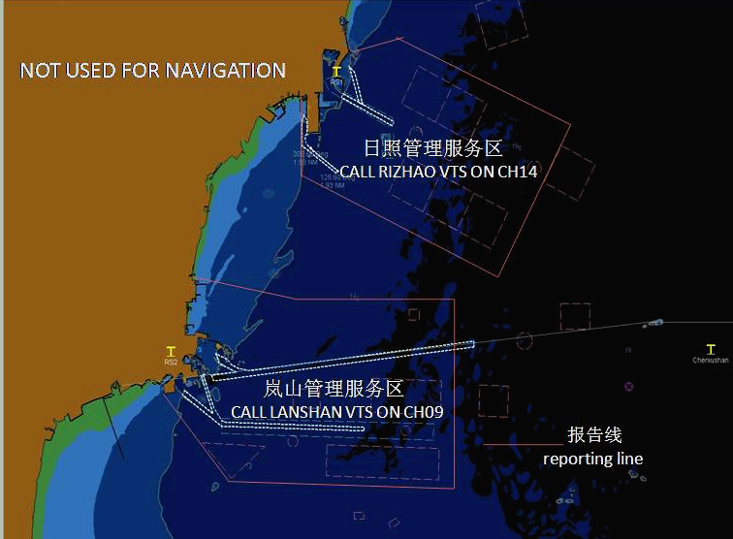

日照VTS雷达盲区
Radar blind area of Rizhao
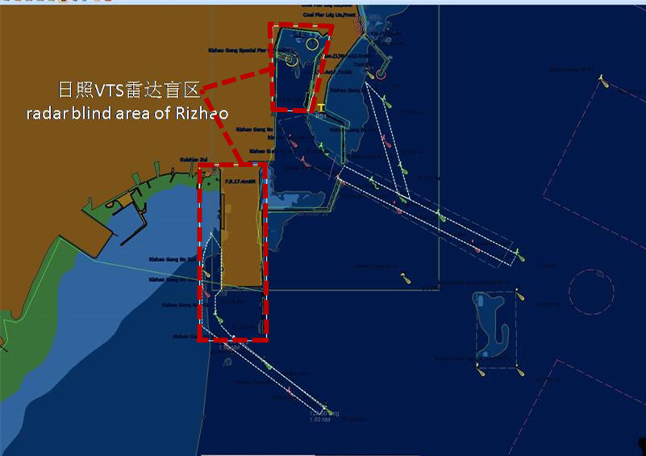

岚山VTS雷达盲区
Radar blind area of Lanshan
